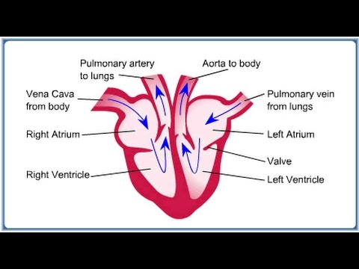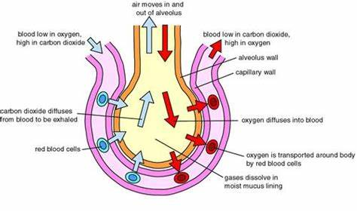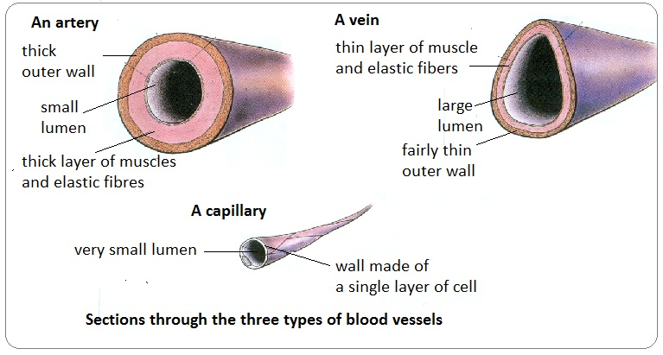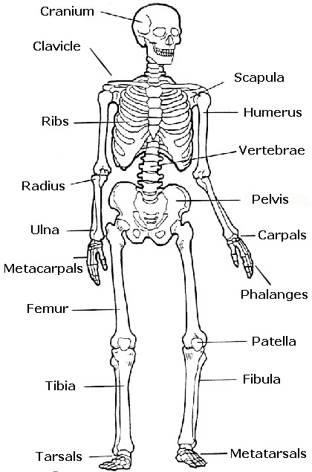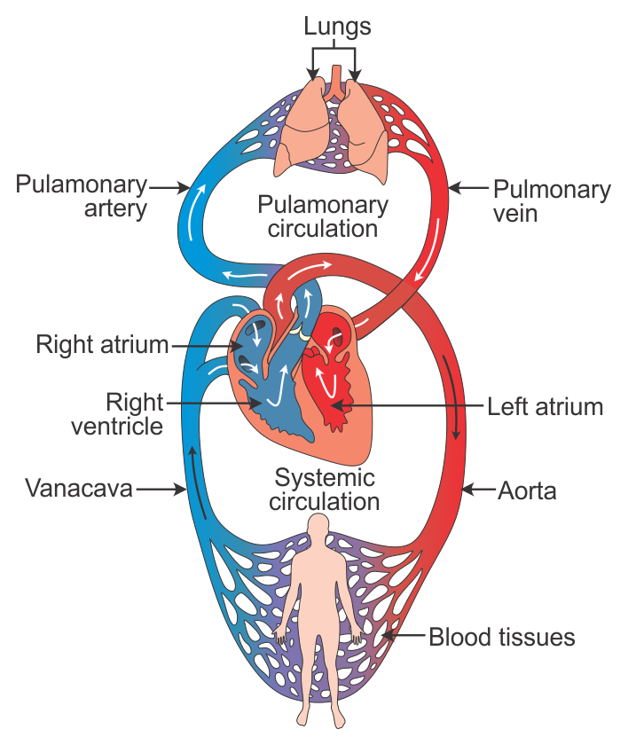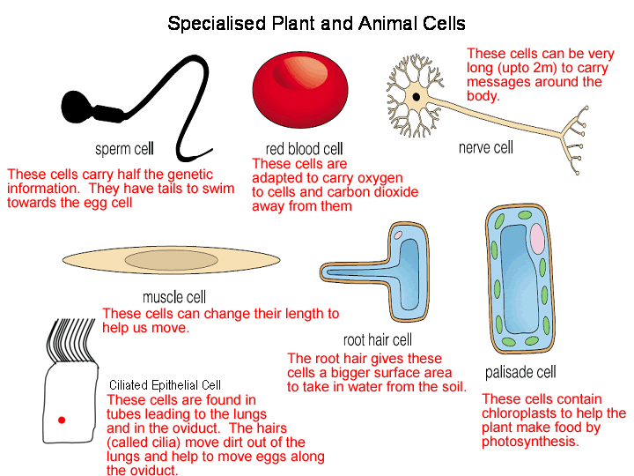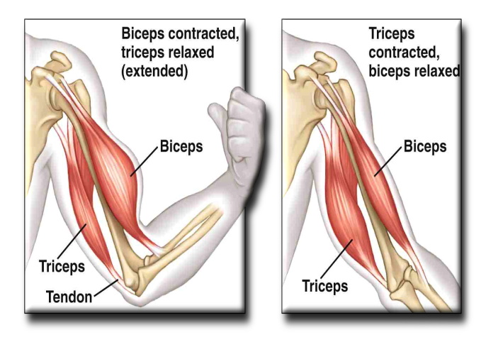

**Cell biologist**

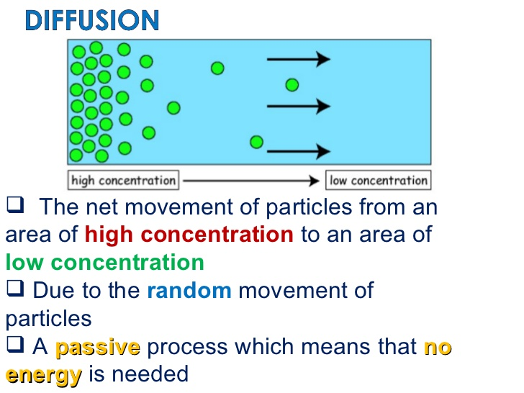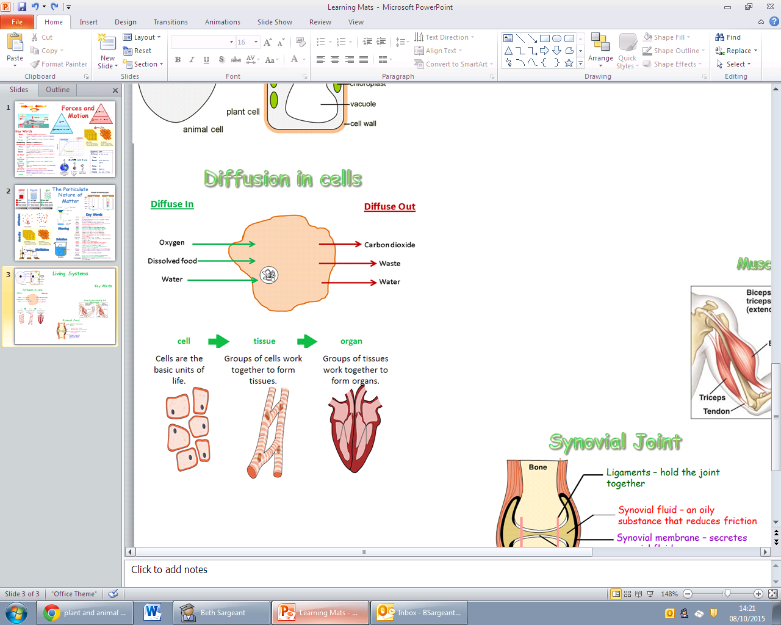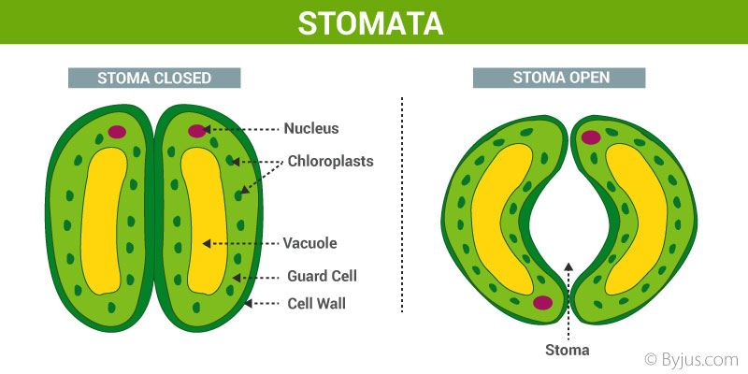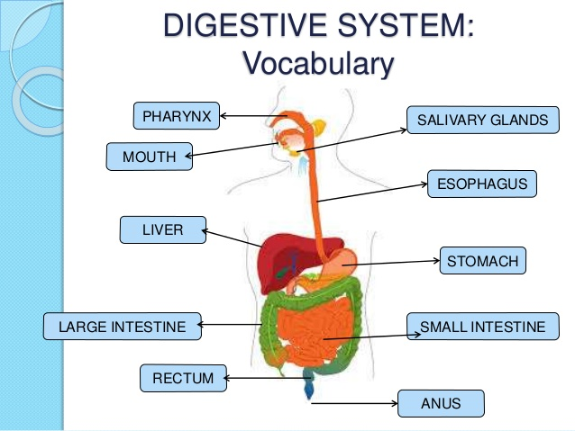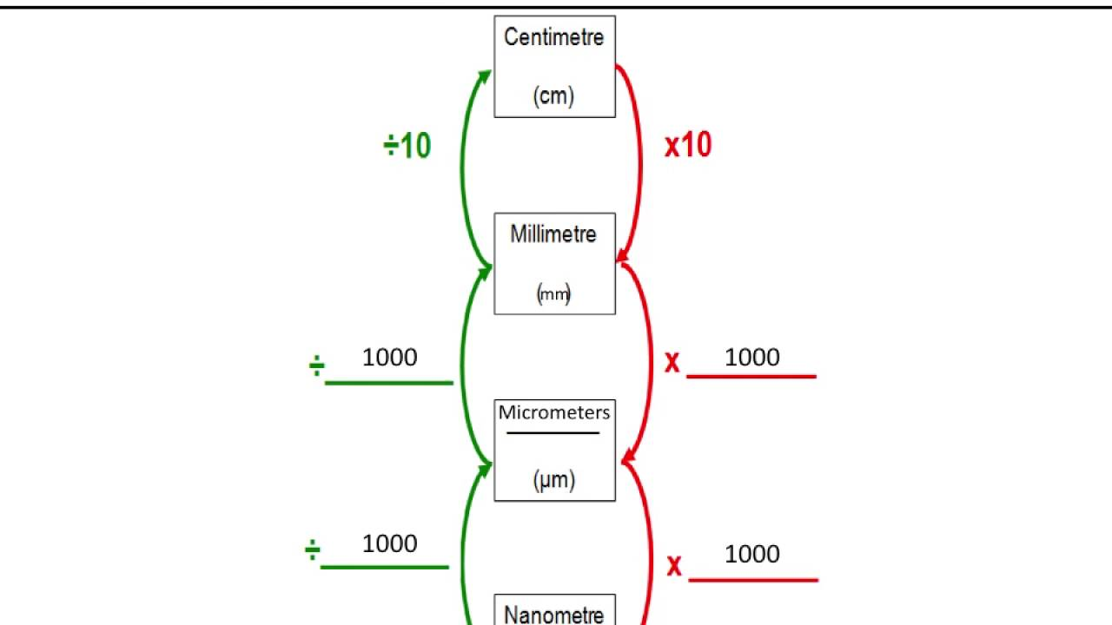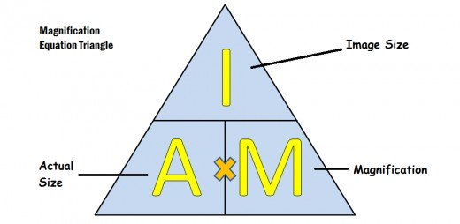[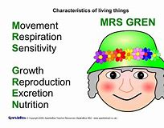](https://www.bing.com/images/search?view=detailV2&ccid=a2G0%2fIjg&id=48E7C97D5FBB8E5BF3374DF24617C7A548674F2C&thid=OIP.a2G0_IjgkBEmTn5nkpfhpwHaFP&mediaurl=http%3a%2f%2fimage.slidesharecdn.com%2fmrs-gren-110203190922-phpapp01%2f95%2fmrsgren-1-728.jpg%3fcb%3d1296760194&exph=515&expw=728&q=MRSGREN&simid=607991262164879650&selectedIndex=1)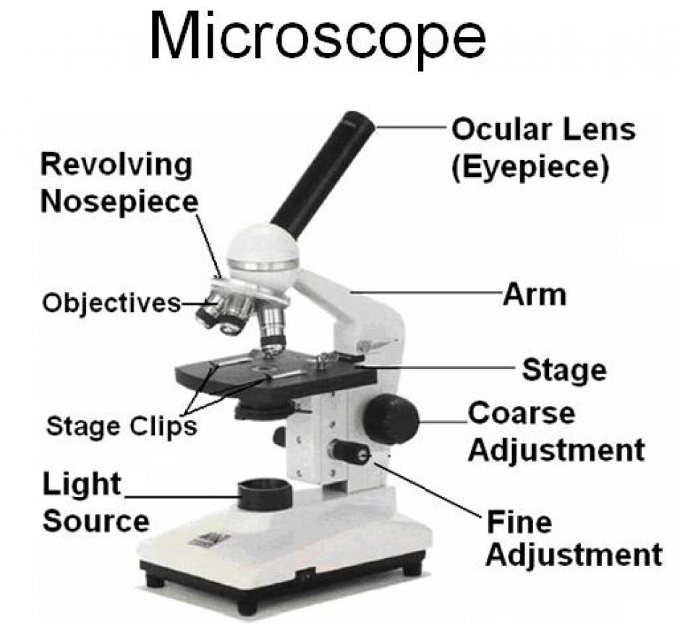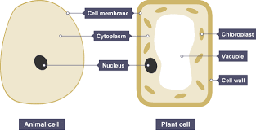

**Cell biologist**