KS3 reactions
Definitions
1 | Exothermic | A chemical reaction that gives out energy | 16 | Thermal decomposition | Breaking down a compound using heat
2 | Endothermic | A chemical reaction that absorbs energy | 17 | Reactants | The things that go into a reaction. There can sometimes be just one reactant or several.
3 | Hydrocarbon | A compound containing hydrogen and carbon atoms only | 18 | Products | The new substances that are made. This can be one product or many.
4 | Combustion | The scientific name for burning. | Equations for complete and incomplete combustion
5 | Complete combustion | Burning a full when there is enough oxygen present. | 19 | Complete combustion | Fuel + oxygen carbon dioxide + water
6 | Incomplete combustion | Burning a full when there is not enough oxygen present. | 20 | Complete combustion | 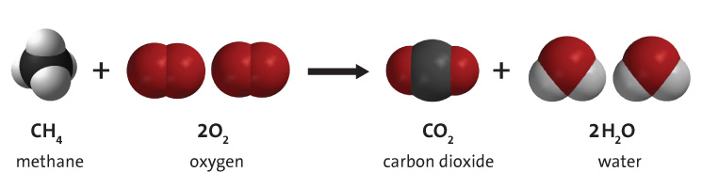
7 | Oxidation | When an element combines with oxygen. E.g Magnesium is oxidised to form magnesium oxide. | 21 | Incomplete combustion | Fuel + limited or no oxygen carbon monoxide  + water
8 | Reduction | When oxygen is removed form a compound e.g Magnesium oxide is reduced to form magnesium + oxygen | 22 | Incomplete combustion | Fuel + limited or no oxygen carbon + water
9 | Carbon monoxide | A toxic gas produced from incomplete combustion. Can be lethal. | 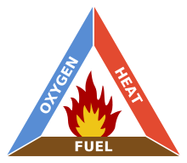 |  |  | 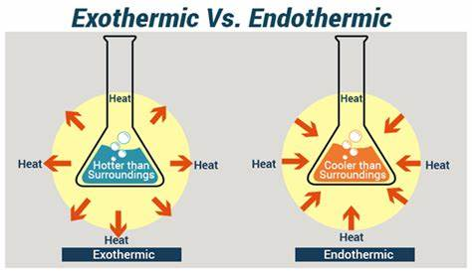
10 | Word equation | Contains the names of the reactants and products in a chemical reaction
11 | Fuel | A substance that burns to release energy.
12 | Conservation of mass | When a chemical reaction takes place no atoms or gained or lost. Atoms are simply rearranged
13 | Physical reaction | A physical change is a type of change in which the form of matter is altered but one substance is not transformed into another
14 | Chemical reaction | a chemical change that occurs when two or more substances combine to form a new substance.
15 | Precipitate | an insoluble solid that emerges from a liquid solution | Fig 1: Fire triangle

