AQA CHEMISTRY GCSE
Structure of the course:
2 exams;, Chemistry paper 1, Chemistry paper 2,
Each exam is assessed • Written exam: 1 hour 45 minutes • Foundation and Higher Tier • 100 marks • 50% of GCSE
Questions; Multiple choice, structured, closed short answer, and open response.
Chemistry Knowledge & topics
Chemistry Paper 1 topics  1- Atomic structure  2- The periodic table  3- Structure and bonding  4- Chemical calculations.  5- Chemical changes  6- Electrolysis  7- Energy changes | Chemistry Paper 2 topics  8- Rates and equilibrium  9- Crude oil and fuels  10- Organic reactions  11- Polymers  12- Chemical analysis  13- The Earth’s atmosphere  14- The Earth’s resources  15- Using our resources
Chemistry paper 1 Required Practical’s  1- Making salts  2- Titration  3- Electrolysis  4- Temperature changes | Chemistry paper 2 Required Practical’s  4- Rates of reaction  5- Chromatography  6- Identifying ionic compounds  7- Water purification

Science Subject Specific Vocabulary
Accuracy- A measurement result is considered accurate if it is judged to be close to the true value.
Calibration- Marking a scale on a measuring instrument. For example, placing a thermometer in melting ice to see whether it reads zero, in order to check if it has been calibrated correctly.
Data- Information, either qualitative or quantitative, that has been collected.
Error- See also uncertainty.
Measurement error- The difference between a measured value and the true value.
Anomalies- These are values in a set of results which are judged not to be part of the variation caused by random uncertainty.
Random error- These cause readings to be spread about the true value, due to results varying in an unpredictable way from one measurement to the next. The effect of random errors can be reduced by making more measurements and calculating a new mean.
Systematic error- Sources of systematic error can include the environment, methods of observation or instruments used. Systematic errors cannot be dealt with by simple repeats. If a systematic error is suspected, the data collection should be repeated using a different technique or a different set of equipment, and the results compared.
Zero error Any indication that a measuring system gives a false reading when the true value of a measured quantity is zero, e.g. the needle on an ammeter failing to return to zero when no current flows. A zero error may result in a systematic uncertainty.
Fair test A fair test is one in which only the independent variable has been allowed to affect the dependent variable.
Hypothesis A proposal intended to explain certain facts or observations.
Interval The quantity between readings, e.g. a set of 11 readings equally spaced over a distance of 1 metre would give an interval of 10 centimetres.
Precision Precise measurements are ones in which there is very little spread about the mean value. Precision depends only on the extent of random errors – it gives no indication of how close results are to the true value.
Prediction A prediction is a statement suggesting what will happen in the future, based on observation, experience or a hypothesis.
Range The maximum and minimum values of the independent or dependent variables; important in ensuring that any pattern is detected. For example a range of distances may be quoted as either: 'From 10 cm to 50 cm' or 'From 50 cm to 10 cm'.
Repeatable A measurement is repeatable if the original experimenter repeats the investigation using same method and equipment and obtains the same results. Previously known as reliable.
Reproducible A measurement is reproducible if the investigation is repeated by another person, or by using different equipment or techniques, and the same results are obtained. Previously known as reliable.
Resolution This is the smallest change in the quantity being measured (input) of a measuring instrument that gives a perceptible change in the reading.
Sketch graph A line graph, not necessarily on a grid, that shows the general shape of the relationship between two variables. It will not have any points plotted and although the axes should be labelled they may not be scaled.
True value This is the value that would be obtained in an ideal measurement.
Uncertainty The interval within which the true value can be expected to lie, with a given level of confidence or probability, eg 'the temperature is 20 °C ± 2 °C, at a level of confidence of 95%'.
Validity Suitability of the investigative procedure to answer the question being asked. For example, an investigation to find out if the rate of a chemical reaction depended upon the concentration of one of the reactants would not be a valid procedure if the temperature of the reactants was not controlled.
Valid conclusion A conclusion supported by valid data, obtained from an appropriate experimental design and based on sound reasoning.
Variables These are physical, chemical or biological quantities or characteristics.
Categoric Categoric variables have values that are labels, eg names of plants or types of material.
Continuous Continuous variables can have values (called a quantity) that can be given a magnitude either by counting (as in the case of the number of shrimp) or by measurement (eg light intensity, flow rate etc). Previously known as discrete variable.
Control Control variable is one which may, in addition to the independent variable, affect the outcome of the investigation and therefore has to be kept constant or at least monitored.
Dependent Dependent variable is the variable of which the value is measured for each and every change in the independent variable.
Independent Independent variable is the variable for which values are changed or selected by the investigator

Science specific command words
Calculate- use numbers given to work out the answer.
Choose- select from a range of alternatives.
Compare- describe similarities &/or differences between things, not just write about one.
Complete- write answers in space provided (diagram, sentence or table).
Define- specify the meaning.
Describe- recall facts, events or process in an accurate way.
Design- set out how something will be done.
Determine- use data or information to obtain and answer.
Draw- produce or add to a diagram.
Estimate- assign an approximate value.
Evaluate- use information supplied as well as their knowledge and understanding to consider evidence for and against.
Explain- make something clear, state reasons for something happening.
Give- short answer required, no explanation or description.
Identify- name or characterise
Justify- use evidence from info given to support an answer.
Label- provide appropriate names on a diagram.
Measure- Find an item of data for a given quantity.
Name- Short answer required, no explanation or description, single word, phrase or sentence.
Plan- Write a method.
Plot- Mark on a graph using data given.
Predict- Plausible outcome.
Show- Structured evidence to reach a conclusion.
Sketch- Draw approximately.
Suggest- Need to apply knowledge and understanding to a new situation.
Use- Answer based on info given in question, or no marks can be given. Could be asked to use own knowledge and understanding.
Work out- Students should use numbers given in the question to work out answer.
Write- Short answer required, no explanation or description.

- Development of scientific thinking
WS 1.1 Understand how scientific methods and theories develop over time. | Give examples to show how scientific methods and theories have changed over time.  Explain, with an example, why new data from experiments or observations led to changes in models or theories.  Decide whether or not given data supports a particular theory.
WS 1.2 Use a variety of models such as representational, spatial, descriptive, computational and mathematical to solve problems, make predictions and to develop scientific explanations and understanding of familiar and unfamiliar facts. | Recognise/draw/interpret diagrams.  Translate from data to a representation with a model.  Use models in explanations, or match features of a model to the data from experiments or observations that the model describes or explains.  Make predictions or calculate quantities based on the model or show its limitations.  Give examples of ways in which a model can be tested by observation or experiment
WS 1.3 Appreciate the power and limitations of science and consider any ethical issues which may arise. | Explain why data is needed to answer scientific questions, and why it may be uncertain, incomplete or not available.  Outline a simple ethical argument about the rights and wrongs of a new technology.
WS 1.4 Explain every day and technological applications of science; evaluate associated personal, social, economic and environmental implications; and make decisions based on the evaluation of evidence and arguments. | Describe and explain specified examples of the technological applications of science.  Describe and evaluate, with the help of data, methods that can be used to tackle problems caused by human impacts on the environment.
WS 1.5 Evaluate risks both in practical science and the wider societal context, including perception of risk in relation to data and consequences. | Give examples to show that there are hazards associated with science-based technologies which have to be considered alongside the benefits.  Suggest reasons why the perception of risk is often very different from the measured risk (e.g. voluntary vs imposed risks, familiar vs unfamiliar risks, visible vs invisible hazards).
WS 1.6 Recognise the importance of peer review of results and of communicating results to a range of audiences. | Explain that the process of peer review helps to detect false claims and to establish a consensus about which claims should be regarded as valid.  Explain that reports of scientific developments in the popular media are not subject to peer review and may be oversimplified, inaccurate or biased
2. Experimental skills and strategies
WS 2.1 Use scientific theories and explanations to develop hypotheses. | Suggest a hypothesis to explain given observations or data
WS 2.2 Plan experiments or devise procedures to make observations, produce or characterise a substance, test hypotheses, check data or explore phenomena. | Describe a practical procedure for a specified purpose. Explain why a given practical procedure is well designed for its specified purpose.  Explain the need to manipulate and control variables. Identify in a given context:  • the independent variable as the one that is changed or selected by the investigator  • the dependent variable that is measured for each change in the independent variable  • control variables and be able to explain why they are kept the same.  Apply understanding of apparatus and techniques to suggest a procedure for a specified purpose.
WS 2.3 Apply a knowledge of a range of techniques, instruments, apparatus, and materials to select those appropriate to the experiment | Describe/suggest/select the technique, instrument, apparatus or material that should be used for a particular purpose, and explain why
WS 2.4 Carry out experiments appropriately having due regard for the correct manipulation of apparatus, the accuracy of measurements and health and safety considerations. | Identify the main hazards in specified practical contexts.  Suggest methods of reducing the risk of harm in practical contexts
WS 2.5 Recognise when to apply a knowledge of sampling techniques to ensure any samples collected are representative. | Suggest and describe an appropriate sampling technique in a given context
WS 2.6 Make and record observations and measurements using a range of apparatus and methods. | Read measurements off a scale in a practical context and record appropriately.
WS 2.7 Evaluate methods and suggest possible improvements and further investigations. | Assess whether sufficient, precise measurements have been taken in an experiment.  Evaluate methods with a view to determining whether or not they are valid.
- Analysis and evaluation
WS 3.1 Presenting observations and other data using appropriate methods. | Construct and interpret frequency tables and diagrams, bar charts and histograms.  Plot two variables from experimental or other data
WS 3.2  Translating data from one form to another. | Translate data between graphical and numeric form.
WS 3.3 Carrying out and represent mathematical and statistical analysis. | For example:  • use an appropriate number of significant figures  • find the arithmetic mean and range of a set of data  • construct and interpret frequency tables and diagrams, bar charts and histograms  • make order of magnitude calculations  • change the subject of an equation  • substitute numerical values into algebraic equations using appropriate units for physical quantities  • determine the slope and intercept of a linear graph  • draw and use the slope of a tangent to a curve as a measure of rate of change  • understand the physical significance of area between a curve and the x-axis and measure it by counting squares as appropriate.
WS 3.4 Representing distributions of results and make estimations of uncertainty. | Apply the idea that whenever a measurement is made, there is always some uncertainty about the result obtained.  Use the range of a set of measurements about the mean as a measure of uncertainty.
WS 3.5 Interpreting observations and other data (presented in verbal, diagrammatic, graphical, symbolic or numerical form), including identifying patterns and trends, making inferences and drawing conclusions | Use data to make predictions.  Recognise or describe patterns and trends in data presented in a variety of tabular, graphical and other forms.  Draw conclusions from given observations.
WS 3.6 Presenting reasoned explanations including relating data to hypotheses | Comment on the extent to which data is consistent with a given hypothesis.  Identify which of two or more hypotheses provides a better explanation of data in a given context
WS 3.7 Being objective, evaluating data in terms of accuracy, precision, repeatability and reproducibility and identifying potential sources of random and systematic error. | Apply the following ideas to evaluate data to suggest improvements to procedures and techniques.  • An accurate measurement is one that is close to the true value. • Measurements are precise if they cluster closely.  • Measurements are repeatable when repetition, under the same conditions by the same investigator, gives similar results.  • Measurements are reproducible if similar results are obtained by different investigators with different equipment.  • Measurements are affected by random error due to results varying in unpredictable ways; these errors can be reduced by making more measurements and reporting a mean value.  • Systematic error is due to measurement results differing from the true value by a consistent amount each time.  • Any anomalous values should be examined to try to identify the cause and, if a product of a poor measurement, ignored.
WS 3.8 Communicating the scientific rationale for investigations, methods used, findings and reasoned conclusions through paper-based and electronic reports and presentations using verbal, diagrammatic, graphical, numerical and symbolic forms. | Present coherent and logically structured responses, using the ideas in 2 Experimental skills and strategies and 3 Analysis and evaluation, applied to the required practicals, and other practical investigations given appropriate information.
- Scientific vocabulary, quantities, units, symbols and nomenclature
WS 4.1 Use scientific vocabulary, terminology and definitions.  WS 4.2 Recognise the importance of scientific quantities and understand how they are determined.  WS 4.3 Use SI units (eg kg, g, mg; km, m, mm; kJ, J) and IUPAC chemical nomenclature unless inappropriate.  WS 4.4 Use prefixes and powers of ten for orders of magnitude (eg tera, giga, mega, kilo, centi, milli, micro and nano).  WS 4.5 Interconvert units.  WS 4.6 Use an appropriate number of significant figures in calculation. | The knowledge and skills in this section apply across the specification, including the required practicals.

Mathematical requirements
1 Arithmetic and numerical computation
a Recognise and use expressions in decimal form
b Recognise and use expressions in standard form
c Use ratios, fractions and percentages
d Make estimates of the results of simple calculations
2 Handling data
a Use an appropriate number of significant figures
b Find arithmetic means
c Construct and interpret frequency tables and diagrams, bar charts and histograms
h Make order of magnitude calculations
3 Algebra
a Understand and use the symbols: =, <, <<, >>, >, ∝ , ~
b Change the subject of an equation
c Substitute numerical values into algebraic equations using appropriate units for physical quantities (chemistry & physics questions only)
4 Graphs
a Translate information between graphical and numeric form
b Understand that y = mx + c represents a linear relationship
c Plot two variables from experimental or other data
d Determine the slope and intercept of a linear graph
e Draw and use the slope of a tangent to a curve as a measure of rate of change (chemistry and physics questions only)
5 Geometry and trigonometry
b Visualise and represent 2D and 3D forms including two dimensional representations of 3D objects (chemistry and physics questions only)
c Calculate areas of triangles and rectangles, surface areas and volumes of cubes

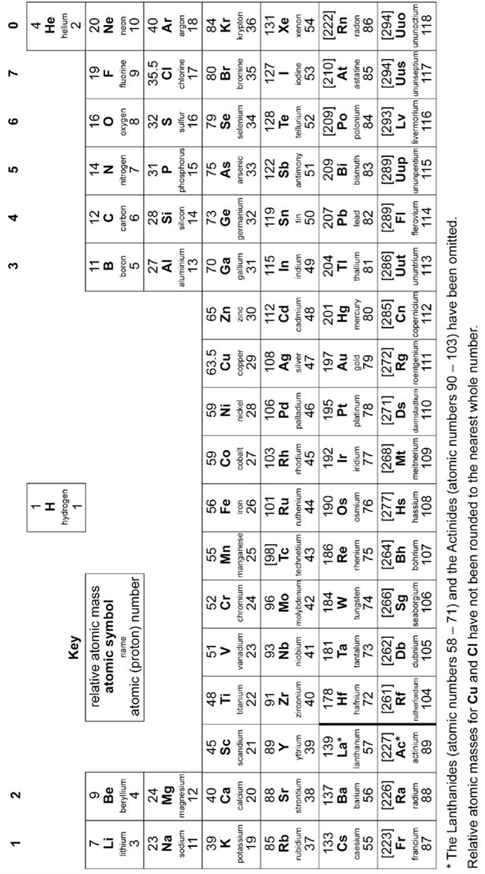

Chemical calculation equations to learn

Note: M_{r} = relative formula mass; A_{r} = relative atomic mass
Moles = mass / M_{r}

Moles = mass / A_{r}

When given abundance of isotopes use:

A_{r} = SUM OF (isotope abundance x A_{r}) / 100

Percentage yield = actual mass / predicted mass

Percentage atom economy = M_{r} of desired product / M_{r} of all the reactants

Concentration (g/dm³) = mass of solute (g) / volume of solution (dm³)

Moles of gas = volume of gas (dm³) / 24dm³

Mean rate of reaction = quantity of reactant used / time

Mean rate of reaction = quantity of product formed / time

R_{f} = distance moved by substance / distance moved by solvent

