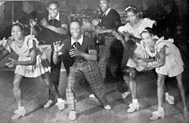
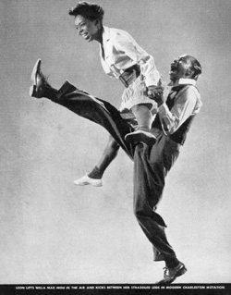
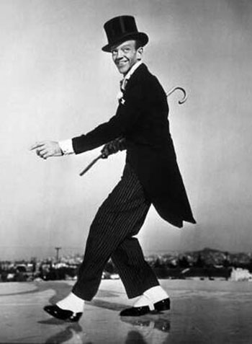
‘Lindy Hop’
In its development, the Lindy Hop combined elements of both partnered and solo dancing by using the movements and improvisation of black dances along with the formal eight-count structure of European partner dances. This is most clearly illustrated in the Lindy's basic step, the swingout. In this step's open position, each dancer is generally connected hand-to-hand; in its closed position, men and women are connected as though in an embrace. The dance can be wild and spontaneous, with frenzied kicks and body movements, or it can be cool and sophisticated. The Lindy Hop is considered a cultural phenomenon that broke through the race barrier when segregation was still the norm. Modern dancers, interested in cultural history are piecing together the roots of Lindy through the tales and film footage of the original dancers, now in their 70s and 80s. Although the history of Lindy may be muddled, it is certain that it was born from the blending of African rhythms and movements with European structured dance and is closely linked to Rock and Roll.
The Lindy Hop (or Lindy) is an American dance that evolved in Harlem, New York City in the 1920s and 1930s and originally evolved with the Jazz music of that time. Lindy was a fusion of many dances that preceded it or were popular during its development but is mainly based on Jazz, Tap, Breakaway, Charleston and Rock & Roll. It is frequently described as a Jazz dance and is a member of the swing dance family.

Creative Task
Research further on ‘Lindy Hop’ dance. View some clips on youtube. Have a go at creating a short piece of dance, incorporating some of the ‘Lindy’ style (as a solo performer). If you are able to do so, film your performance. Evaluate: WWW & EBI….what did you do well? What have you learnt? What could you improve?

